Design, Implementation and Case Study of a Pragmatic Vibrotactile Belt
Jacob Rosenthal, Nathan Edwards, Daniel Villanueva, Sreekar Krishna, Troy McDaniel and Sethuraman Panchanathan, Fellow, IEEE
Abstract—Recently, much research in the area of haptic technologies has focused on the development of waist-worn vibrotactile belts as substitution or augmentation modalities for audio-visual information. Vibrotactile belts have been used in varied applications such as navigational aids, spatial orientation display and balance control. Researchers have mostly focused on the functionality of these vibrotactile belts for specific applications, while neglecting performance and usability. Considering the versatility of a vibrotactile belt, we previously conducted a study on the design requirements for vibrotactile belts, and introduced an implementation based on these design guidelines. This paper builds on our previous work, and provides details for the implementation of a ubiquitous wearable vibrotactile belt. A case study is presented in which the proposed belt was used by a researcher for a novel application of teaching participants choreographed dance. The usability of the belt is demonstrated from the researcher’s perspective in terms of functionality and performance, and from the participants’ perspectives in terms of usability attributes such as comfort and unobtrusiveness.

Index Terms—Human factors, tactile displays, user centered design, vibrotactile learning tool, situational awareness.
- Introduction
AUDIO and video have become the de facto delivery modality when it comes to most commercial human machine interfaces. This is primarily due to the fact that, for humans, audio and visual mediums offer an incredible amount of bandwidth in data delivery. However, the amount of information being delivered to users is ever increasing, and reliance on visual and auditory modalities alone is causing information overload. Further, there are situations where the use of vision and/or hearing may be inappropriate, regardless of whether or not they are available for use. For example, people who are blind or visually impaired do not have access to the visual medium, and their predisposition is to largely rely on audible signals for vital cues from their environment [1]. In such cases, delivering additional information either through vision or audio can be of little or no help; in fact, this may cause unnecessary cognitive overload for the user. Hence, there is a growing need for an alternate communication channel, such as the human skin which is largely underutilized [2].
Of all the modalities that engage the human somatosensory system, vibrotactile stimulation has become very popular in the recent past due to the sophistication and unobtrusiveness of vibrotactile displays [3], as well as their portability and wearability [2]. But this new modality is far from displacing the primary delivery modalities due to the fact that haptics (touch) is a low bandwidth channel compared to audio or video. Previously, complex vibratory pulses have been designed using combinations of vibration dimensions [4][5], such as vibration frequency, amplitude, duration, rhythm and location, and by using human psychophysical perception (like sensory saltation [6]). There are infinite ways to map meanings to vibration dimensions, but conceptually, there are two extremes: symbolic and literal. On one end of the spectrum, tactons [7], or tactile icons, use a symbolic mapping to arbitrarily assign meaning to vibration dimensions. On the other end, a literal mapping assigns vibrotactile cues to intuitive somatosensory signals that humans are already acquainted with, such as a shoulder tap to obtain one’s attention. Encoding schemes may also fall somewhere in between such that the vibrotactile cues may be intuitive, but still require training. Studies on symbolic and literal mappings have shown an extraordinary increase in information delivery bandwidth for vibratory cues, thereby making a case for vibrotactile stimulation as a potential alternative (or at least an augmentation) to audio and video.
  - Motivation
Vibrotactile displays have been implemented in a variety of form factors including desktop displays, handheld devices, and wearable systems, such as gloves [8], jackets [9], and jewelry [10]. In this paper we focus our discussion to vibrotactile displays worn around the waist, commonly referred to in the literature as haptic or vibrotactile belts. Vibrotactile belts have found a number of applications including, but not limited to, pedestrian navigation [11][12][13] (vibrations guide users from a starting point to their destination); balance control [14] for people with vestibular damage (vibrations convey tilt information); virtual reality [15] (vibrations indicate collisions with virtual objects); spatial orientation aids for pilots [16] and astronauts [17] (vibrations provide spatial orientation towards magnetic north or Earth’s gravity vector in zero-gravity environments); psychophysical study of human vibrotactile perception [5][18] (experiments on vibrotactile spatial acuity, spatio-temporal pattern perception, saltation, etc.); and social interaction assistant aids [19] for individuals who are blind or visually impaired (vibrations are used to communicate nonverbal cues). Unlike other form factors, belts tend to be physically discreet and part of almost all everyday clothing. A variety of vibrotactile belt designs and implementations have been proposed in the literature (please refer to Section II for a detailed analysis). However, existing designs have two primary limitations: (1) Limited applicability due to application-specific designs; and (2) Usability and performance requirements tend to be secondary to functionality, thereby forcing readers to question the real-world use of the application itself. This is the natural inclination of a technology-centric, as opposed to human-centric, approach towards interface design. A human-centered design strategy critically accounts for all users of the technology throughout the lifecycle of the design and development of a human machine interface. In this work, we generalize the scope of our users to include both customers: end users of a specific technology; and developers (engineers, scientists, and researchers): those modifying the product for novel applications.
The work presented here is largely motivated by our earlier work [19] in which we investigated the use of a vibrotactile belt as a component of a Social Interaction Assistant through which non-verbal cues were conveyed to individuals who are blind or visually impaired. During the course of over one year of usability testing and experimentation, we collected feedback from participants (and ourselves as developers/researchers) regarding the shortcomings of the belt design. We found the belt to have the following disadvantages in terms of functionality: (1) tactors were fixed, limiting scalability and reconfigurability; (2) only vibration timing and rhythm could be changed, and hence applications that required changes in vibration frequency or amplitude could not be pursued; and (3) the belt was not wireless, preventing realistic usability studies. The most common complaints from users of the belt were (1) difficulty adapting to different waist sizes given the fixed tactors; (2) the cumbersome nature given the bulkiness of the belt and the wired implementation; and (3) the use of Velcro which often became detached. This work primarily aims to overcome all the above concerns and document a pragmatic design guideline for vibrotactile belts.
  - Contributions
In our recent work [1], we addressed the aforementioned limitations through a human-centric approach toward designing and building a vibrotactile belt. Design guidelines (Section III) were derived from both existing guidelines on the design of vibrotactile wearables [15][20], and participant comments regarding desired functionality, performance and usability traits. This paper extends on our work [1] through two important contributions. First, the hardware and software designs are provided here in elaborate detail to allow replication of our work (Section IV, V and VI), with clear explanations of implementation choices and design considerations. Secondly, this paper elaborates on the pilot study presented in [1] and presents a case study (Section VII) in which the functionality, performance and usability of the proposed belt were assessed under a realistic experimental condition: a researcher used our belt in a novel pedagogical application for teaching choreographed dance through vibrotactile cues. Lastly, Section VIII presents possible directions for future work.
- Related Work
Our literature survey revealed over twenty vibrotactile belt designs from academic publications and electronics hobby forums. We’ve selected a subset for discussion here based on the maturity of their implementation and availability of information regarding implementation details.
Cholewiak et al. [18] introduced a reconfigurable and scalable haptic belt design for use in human haptic perception experiments, where vibration motors were wired directly to a waveform generator, and attached via Velcro onto an elastic belt. The belt was specifically intended for psychophysical experiments, and its wired implementation limits portability, ease of movement, unobtrusiveness and discreetness. Van Erp et al. [11] presented a wireless, elastic vibrotactile belt for waypoint navigation. The belt consisted of eight vibration motors with adjustable locations. The belt was controlled by a minicomputer placed inside a backpack worn by the user. The paper provides no information regarding the scalability of the belt, i.e., the option of removing or adding vibration motors. Moreover, it is unclear if the amplitude and/or frequency of the vibrations can be adjusted. For studying human haptic perception, Jones and Ray [5] built a wireless haptic belt made of fabric consisting of 8 vibration motors held by Velcro. A back display was also constructed, which consisted of a four-by-four matrix of vibration motors. The locations of the vibration motors were adjustable, but the paper does not mention whether amplitude or timing could be controlled, nor is there any mention of the capability to add or remove vibration motors. Further, the bulkiness of the system, and its excessive cabling, could limit ease of movement, unobtrusiveness and discreetness.
ActiveBelt [13] is a wireless haptic belt for pedestrian navigation, among other applications. The belt consisted of eight fixed vibration modules with elastic between vibration sites and used a large, onboard processing unit. Dimensions of the vibratory signals, such as frequency and timing, could be altered, but the reconfigurability and scalability of ActiveBelt is limited given its fixed vibration motors. Further, although the paper claims universal accessibility in that the belt can adapt to varying waist sizes, this may be only partially true—from our own past experiences, extreme waist sizes (either very small or very large) may not be able to use such an implementation.
Ferscha et al. [21] presented a wireless vibrotactile belt for spatial awareness. Vibratory dimensions, such as intensity and timing, could be altered in a portable and lightweight design. However, since the belt used eight fixed vibration motors, its reconfigurability and scalability is limited. The Tactile Wayfinder [12], by Heuten et al., is a wireless vibrotactile belt for pedestrian navigation. It has many of the same advantages and disadvantages of Ferscha et al.’s belt design, but with a few differences; one advantage being The Tactile Wayfinder has an available API for application creation.
Perhaps the most accomplished of the aforementioned belt designs is the TactaBelt by Lindeman et al. [15], which consisted of eight vibration motors connected via Velcro to neoprene. The vibration motors of the belt are reconfigurable and scalable, and their vibratory dimensions are adjustable. Although the TactaBelt is functional and rich in features, there is little to no discussion regarding the usability and performance of the belt—this is also a reoccurring problem with all aforementioned belt designs. The rigidness and durability of this belt is questionable given that vibration motors were attached to the belt via Velcro. Whereas this solution may work in controlled environments, such as a virtual reality setup in a laboratory, it’s unlikely to work well in real world conditions and under everyday use.
- Design Requirements
Identifying the shortcomings of vibrotactile belt designs, reviewing existing design guidelines in the literature, and combining these with our own past experiences, we’ve compiled a set of design requirements for vibrotactile belts, depicted in Table I.
In the above table, usability is the most important metric that captures the capability of a haptic platform to be used for exploring novel applications; in other words, if there are usability issues in a research platform, it will bias the outcome of any research experiment, thereby distracting the researcher from the true outcomes of an experiment. Following usability, functionality takes the next higher precedence, as it allows a researcher to configure the device to his or her novel application needs. Offering higher functionality allows adaptability of the research platform to various experiments. Finally, performance captures the lenience offered by the platform during experimental use. Mostly, higher performance reduces the researcher’s requirement to focus attention on the research platform, and allows him/her to focus on the study itself. We discuss some of the existing work in eliciting such design requirements for vibrotactile belt and add design considerations that we have identified through our experience.
Regarding the usability of a vibrotactile belt, Lindeman et al. [15] described a vibrotactile wearable device with limited cumber as one that is easy to put on or take off, and doesn’t hinder movement with excessive wiring and bulky modules. Adding to this description of limited cumber, we include factors such as comfort and unobtrusiveness [20], ergonomics, lightweight and adaptability to fit different waist sizes. A vibrotactile belt should be intuitive so that it is easy to learn to use from both an end-user’s perspective, as well as a developer’s perspective. The latter will have much more vested interest in reconfiguring the belt for his or her intended application. Lastly, a vibrotactile belt should be discreet in that it is physically discreet and silent. As belts are a common part of everyday attire, keeping the design of vibrotactile belts close to accustomed dressing attire will help gain wider acceptance among users. Vibration motors can be noisy, which when used in public, can be distracting to those around us. Hence, vibrotactile modules should be designed to reduce noise.
Table I: Design Requirements for Vibrotactile Belts.
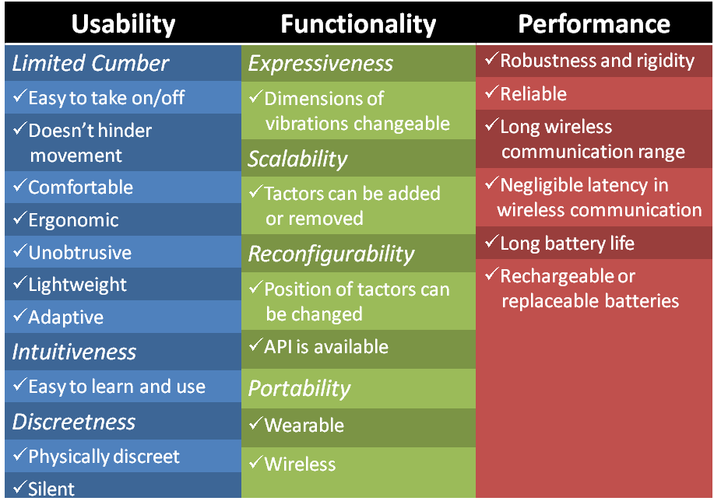
Lindeman et al. [15] proposed three functionality attributes: expressiveness, scalability and reconfigurability as being important for a vibrotactile display. The first attribute, expressiveness, was met by providing variability of vibration dimensions: intensity, timing and location. However, the paper gives little detail about what exactly defines scalability and reconfigurability of a vibrotactile belt. We extend their work to define scalability as the capability to add/remove tactors to/from a vibrotactile belt without performance degradation; and reconfigurability, which is related to the adaptability of the belt to different applications and uses, is defined as the capability to (1) easily change the placement of tactors on a vibrotactile belt, and (2) easily change the vibrotactile belt’s functions through an Application Programming Interface (API). Lastly, portability is an important functionality influenced by its wearability and wireless connectivity.
Attributes that describe performance design requirements include durability, long wireless communication range, negligible latencies in wireless communication, long battery life and replaceable/rechargeable batteries. Although the importance of these attributes will largely depend on an application’s minimum performance requirements, it’s recommended that all of the proposed attributes be taken into account when developing a versatile vibrotactile belt.
As mentioned earlier, the versatility and usefulness of existing vibrotactile belt implementations are severely limited due to an application-specific focus. Such a non-structured approach results in replication of work between researchers and developers. Our goal, through this paper, is to establish a repeatable means of approaching the development of vibrotactile belts. While we discuss most of the design issues in the context of developing vibrotactile belts, we are confident that these guidelines can be immediately extended to any wearable vibrotactile display technology.
- Implementation
  - Form Factor
A belt’s form factor ultimately determines its wearability and portability. To this end, we attempted to make the belt as robust and wearable as possible (see Fig. 1). The control box offers complete belt control along with wireless connectivity and battery power supply, and measures 8 cm by 4 cm by 2 cm. The individual tactor modules enclose a separate controller and a vibration motor, and measure 5.4 cm by 3.49 cm by 1.47 cm. The belt was designed to be lightweight (harness: 92.14 g; each tactor: 21.26 g; and controller: 95.68 g), comfortable and physically discreet.
The belt harness (flat nylon webbing) is easily adjustable to any waist size using plastic buckles while the tactors and control box are on pocket clips and can be adjusted appropriately per application, in seconds. This design was chosen over a Velcro based implementation (popularly encountered in our literature survey) to achieve better adaptability to different waist sizes; to hold tactors very close to the body during use; and to offer robustness and rigidity for real-world applications. The control box and the individual tactors are connected over a 4 -wire I²C bus that carries power along with the data and clock. This configuration, allows plug and play adding, removing and reconfiguring of tactors for scalability and reconfigurability.
  - System Architecture
In order to provide two important functional requirements of expressiveness and scalability, we employ a network of distributed controllers. The hierarchical system level design of the belt, shown in Fig. 2, utilizes an independently functioning wireless main controller (Haptic Belt Controller) enclosed within the control box, and auxiliary controllers (Tactor Controllers) for monitoring and controlling each vibration motor, represented as tactors in Figure 2.
While the main controller offers connectivity to a command control center (PC or PDA), each tactor controller takes care of the micromanagement of vibrotactile cueing at each vibration motor. This multi level hardware processing buffers commands, and consequently allows for a higher performance and responsiveness of the system when compared to a centralized processing system. Each sub-system encapsulates its functionality locally so that it provides functional independence from other sub-systems, all while achieving this with minimal data transmissions. Any shared data is stored centrally on the main controller and is distributed on power-up or redistributed after a configuration change. One of the important design requirements of a haptic belt, reconfigurability, is the capability to configure the belt’s parameters easily with the bare minimum software tools. To this end, the belt connects through character terminal interface with Hayes AT command like serial communication interface.
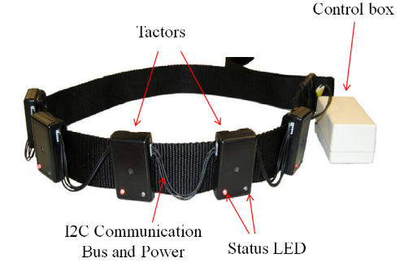
Fig 1: Haptic Belt Harness and Tactor Modules.

- Hardware Design
  - Control Box
The control box receives all control messages transmitted from the command control center (PC or PDA) to the haptic belt. As shown in Fig. 2, the most important components of the control unit are as follows:
    - Main Controller
A specific implementation of the popular Arduino Open Source hardware platform (based on Atmel ATMeg168 microcontroller), called Funnel IO, was used for the main controller.
    - Bus Communication
One of the most important requirements for the design of the haptic belt was the need to reduce the number of wires connecting tactors. It was this constraint which led to the use of individual controllers at each of the tactors. Complementing this choice, I²C offered the least number of wires with reliability. Thus, a four wire bus implementation, 2 wires for power, one for data (SDA) and one for clock (SCL), was adopted. The implementation allows up to 16 tactors on the belt simultaneously.
    - Power Supply
Much consideration was given to the possible use time of the belt when specifying and sizing the power supply technology. Considering the space constraints, Lithium-polymer chemistry provides the most charge density for its size, and so a single cell 3.7V 800 mAh battery that allows up to 6 hours of continuous operation was chosen.
    - Wireless Hardware
Our performance requirements for the wireless module included transmission range of a large room, and the inclusion of a separate microcontroller to manage transmission without impacting general controller function. Either of two integrated wireless modules (Digi’s XBee ZigBee module and Roving Network’s RN-41 Bluetooth module) were chosen to connect to the Funnel board through a dedicated UART providing the necessary wireless connectivity and control.
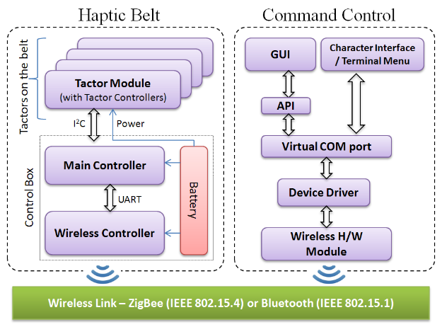
Fig 2: System Architecture.
  - Tactor Modules
As shown in Fig. 2, the tactor modules individually contain a microcontroller that negotiates its role with the main controller through the I²C bus. An Atmel ATtiny88 microcontroller forms the core of the tactor module. The PWM unit on the microcontroller is used for amplitude control and temporal rhythm generation, as described in Software Design (Section VI), while running independently from the main controller. A MOSFET driver provides the necessary switching between the digital output and the motor actuations. Six GPIO pins of the ATtiny88 are configured to read a DIP switch setting that assigns each tactor module’s bus address. This address is used by the main controller to dynamically assign the I²C bus address at startup. This eliminates the need to reprogram all tactor modules for different applications/uses, thereby providing plug-and-play functionality. Vibrations are actuated through use of a 12 mm coin-type shaftless vibration motor, which has a rotational speed of 150Hz and a nominal vibration of 0.9g. The motors were mounted such that the vibration axis is parallel to human skin causing a net lateral vibration along the skin.
- Software Design
The software components of our proposed design contain two important aspects: the firmware, which is programmed on the microcontrollers, and the User Interface (UI) that allows the design of vibrotactile rhythm patterns and access to the operational modes of the haptic belt.
  - Firmware
As explained earlier, the proposed haptic belt system makes use of a distributed microcontroller network framework with a separate main controller and the tactor microcontrollers for increased functionality and reliability. Below we discuss the important aspects of the firmware for the two controllers.

    - Main Controller Firmware
The main controller provides communication between the command control (through wireless protocols) and the tactors on the belt. The main controller’s firmware can be categorized into 7 primary functional areas as shown in Fig. 3.
a) Wireless Communication Module: All communication from the command control center (PC) is received through the ZigBee/Bluetooth wireless module. This module reads and writes data to and from the hardware buffers in a continuous loop. All data received is automatically sent to the Command Parser for further interpretation.
b) Command Parser and ASCII User Interface: This module provides four primary user modes, namely, a) new belt configuration; b) query current configurations; c) test vibrotactile patterns; and d) binary command mode. These modes allow the user to configure, use and debug individual tactors and the belt as a whole.
c) Learn Command Module: In the proposed belt design, versatility is provided through user definitions of the Temporal Rhythm Unit (TRU) and Temporal Rhythm Sequence (TRS) (See Section VI.B). This module handles all the activities of the learning module while building rhythm pattern definitions (TRS and TRUs). This module also sends all new configurations to the Memory management module (via command parser) to be stored in the on-chip memory.
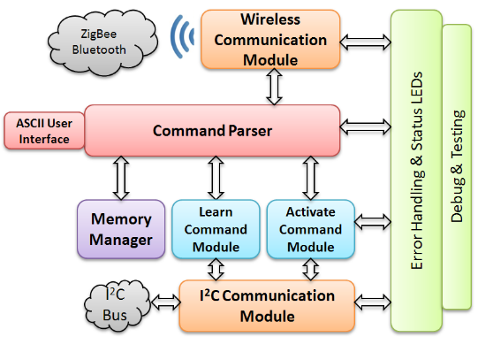
Fig 3: Main Controller Firmware Implementation
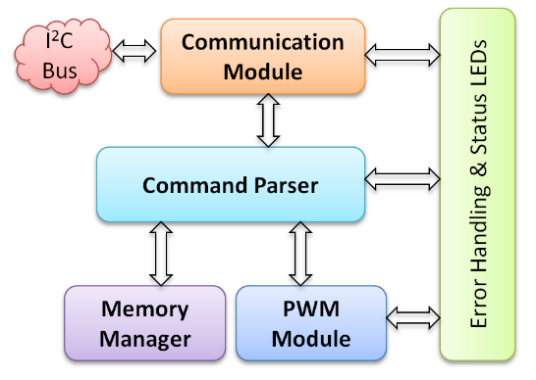
Fig 4: Tactor Controller Firmware Implementation.
d) I²C Communication Module: This module is responsible for querying all tactors (or any devices) on the bus and stores their addresses into a data table. This module is also responsible for sending commands and receiving status codes from all the tactor modules.
e) Memory Manager: The ATmega168 controller has limited SRAM for runtime operations. The memory manager is implemented so that all rhythm definitions or text-based menus can be stored and retrieved from the on-chip Flash memory. The command parser handles the control flow to the memory manager.
f) Activate Command Module: This module handles the binary encoding of a tactor activate command. It packages the requested rhythm (TRS) and magnitude (TRU) with the appropriate cross-referenced tactor bus address and sends the command to the specific tactor for activation.
    - The Tactor Controller
The tactor controller firmware communicates directly with the main controller firmware as a slave device over the I²C bus and maintains the PWM timing for the local vibration motor. A two-byte command structure is used between the main controller and the tactors. Similar to the main controller firmware, the functionality of the tactor controller can be categorized into five important roles (Fig. 4). While the communication module and command parser are similar as above, the memory module and the low-level hardware module (PWM module) form the critical components of the tactor module. The memory manager module is responsible for temporarily storing the definition of the TRU and TRS that are sent over to the tactors at boot up. At run time, a two-byte activate command selects the appropriate TRU and TRS for each tactor, which the PWM module executes on the vibration motor.
  - User Interface
The user interface on the haptic belt currently supports two complementary formats: 1) A console based Hayes AT command set-like interface for quick access to all functionalities of the belt, and 2) an Application Programming Interface (API) for more advanced programming in higher level languages and for Graphical User Interface development.
Currently, we have implemented a PC based and a PDA based GUI for controlling and configuring the haptic belt. The GUI allows the design of complex vibrotactile rhythm and spatio-temporal patterns. The API has the portability of supporting a wide range of ubiquitous computing platforms, including mobile devices. In Fig. 5(a), we show the PDA interface with highlights on some of the important features. While the functionalities on the PC are very similar to the PDA version, additional features on the PC allow easy configurability of the belt. The example feature shown in Fig. 5(b) shows the setup used for designing a TRS. Users can select specific rhythms and vary the TRUs appropriately based on the application. Each TRU is 50 ms long, and the entire TRS can be a maximum of 3 seconds long. The interface allows a user to compose a pattern of patterns by interleaving TRSs. The case study discussed later in this paper used these controls to design haptic patterns related to the study. Our graphical interface is similar to other haptic pattern authoring software like posVibEditor [22], and provides a framework for rendering digitally modulated vibration patterns. As there is a lack of standardization and open sourcing among authoring tools for vibrotactile patterns, our efforts are unique in that our work is available for download, as of this publication.
- Case Study: waist-worn Vibrotactile display for pedagogical application for choreographed Dance
To evaluate the vibrotactile belt’s three important design parameters of usability, functionality and performance, we conducted a case study in which the belt was used for a novel pedagogical application under realistic conditions. A two-fold, quantitative and subjective analysis was conducted to evaluate real-world usability issues. In [1], we demonstrated the general usability of the belt through a pilot study from the user’s perspective, but the functional and performance metrics were not evaluated. In this paper, we delve into the details of the belt’s evaluation through its use as a research platform for a novel application of teaching choreographed dance. While the usability analysis was done from the user’s perspective, the functional and performance analyses were done by an independent researcher who designed and executed the dance study. The researcher was not part of the development team and evaluated the proposed belt as a research platform to impart choreography of simple dance steps to a mixed group of participants with and without dance experience. It is important to note that the researcher who worked with the proposed belt (a) had never used the vibrotactile belt; (b) had limited experience with haptic devices, and had never designed vibrotactile spatio-temporal patterns; and (c) had a novel application design with specific research objectives of determining how effectively choreography can be achieved through wearable vibrotactile devices.
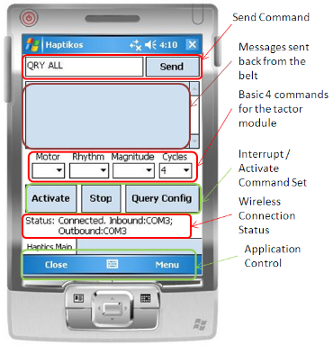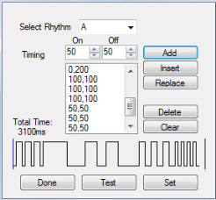
Fig 5: a) Graphical User Interface on a Portable Platform. b) Temporal Rhythm Sequence (TRS) Design Interface.

Related Work in the Use of Vibrotactile Cues for Teaching Dance
In the literature, vibrotactile stimulation to elicit motor movement can be divided into two approaches: feedback-based and instruction-based, both of which are relatively new and unexplored. While feedback based approaches track human body motion and provide feedback whenever there is a deviation from a predefined path [23][24], instruction-based methods assign specific body movements to predesigned vibrotactile patterns, and expect subjects to memorize this mapping. In [25], Drobny et al. developed a wireless sensory system placed in the shoes of ballroom dancers. By measuring the force of taps, the system recognizes any missteps and emphasizes beats acoustically to help partners get back in sync. While this study was centered on a feedback based learning system, this case study uses an instruction-based method for teaching dance (similar to various other pedagogical applications targeting physical activities such as snowboarding [26], bowing [27][28] and swimming [29]), where predefined spatio-temporal vibration patterns require participants to demonstrate specific movements. To the best of the authors’ knowledge, the only other work that explores instruction-based vibrotactile cues for teaching dancing is an approach by Nakamura et al. [30] where vibrotactile cues instructed arm movements for traditional Japanese folk dance. Unfortunately, the paper does not describe any of the proposed vibrotactile cues, and no statistical analysis was presented. Note that the cues proposed here are for basic dance movements only; more complex dance movements will require further exploration by dance experts on the possible redesign of vibrotactile stimulators to be placed in strategic locations on the body.

Subjects
11 males and 2 females of ages 21 to 60 (average: 30) participated in the dance study. No subjects had any tactile impairment around their waist. 5 subjects had never danced before, 4 subjects had less than one year of dance experience, and 4 subjects had a least 5 years of dance experience. The dance participants provided data for analyzing the usability of the belt, while the independent researcher offered evaluations for the functionality and performance of the belt. Although we would have preferred several researchers and/or developers to assess the usability of our belt through their own novel applications and user studies, this was not feasible due to time limitations and the need for a specific target application.

Procedure
The belt was configured with 8 tactors placed equidistantly around each participant’s waist. Fig. 6 shows the configuration with tactor #1 is at the user’s left side, tactor #3 at the user’s navel, tactor #5 at the user’s right side and tactor #7 at the user’s spine.
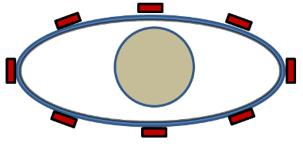
3: Navel
1: Left
2
5: Right
4
6
7: Spine
8
Fig 6: Arrangement of 8 Tactors around the Waist.

Subjects were informed that the purpose of the experiment was to assess how well they can recognize vibrotactile cues. They were not told that they would be learning basic dance moves to avoid giving any advantage to those with prior dance experience. Subjects were given instructions regarding how to put on the belt, and were told to move tactors along the length of the belt to match the configuration shown to them on a printed paper (same as Fig. 6). First, subjects were familiarized with the different vibrotactile patterns and the corresponding body movements (see Table II). Next, participants began the training phase where they were asked to feel a vibrotactile pattern and perform the associated movement, then return to the starting position. 24 trials (12 vibrotactile patterns each presented twice) were randomly presented. Subjects were encouraged to respond within ten seconds. Subjects were required to achieve above 70% accuracy in order to move on to the testing phase. The testing phase consisted of two parts. In the first part, the testing phase was similar to training phase, but with 48 trials and no feedback. Before the second part of the testing phase, participants performed another familiarization phase to help them learn how to link individual moves. In this familiarization phase, participants performed 11 moves in sequence. Finally, participants performed two different dance sequences: a modified box step and a modified electric slide. The modified box step was repeated once, and consisted of the following vibrotactile patterns of Table II, in order: A, B, J, I, F, E, K, and L, as shown in Fig. 7. The modified electric slide was not repeated, and consisted of the following patterns of Table II, in order: J, I, J, I, K, L, K, L, F, E, A, B, B, A, E, F, K, L, K, L, J, I, J, I, A, B, F, E, F, E, A, and B, as shown in Fig. 8. A pause of 2 seconds was given between the pattern presentations. During this phase, no feedback was given to participants regarding right or wrong movements.

Table II. Foot Steps Involved in the Choreographed Dance Movements.
ID | Movement | Vibrotactile Pattern
A | Left foot forward (small step) | 1 – 2 – 3
B | Right foot forward (small step) | 5 – 4 – 3
C | Left foot forward (long step) | 7 – 8 – 1 – 2 – 3
D | Right foot forward (long step) | 7 – 6 – 5 – 4 – 3
E | Left foot back (small step) | 1 – 8 – 7
F | Right foot back (small step) | 5 – 6 – 7
G | Left foot back (long step) | 3 – 2 – 1 – 8 – 7
H | Right foot back (long step) | 3 – 4 – 5 – 6 – 7
I | Left foot right | 1 – 2 – 3 – 4 – 5
J | Right foot right | 3 – 4 – 5
K | Left foot left | 3 – 2 – 1
L | Right foot left | 5 – 4 – 3 – 2 – 1

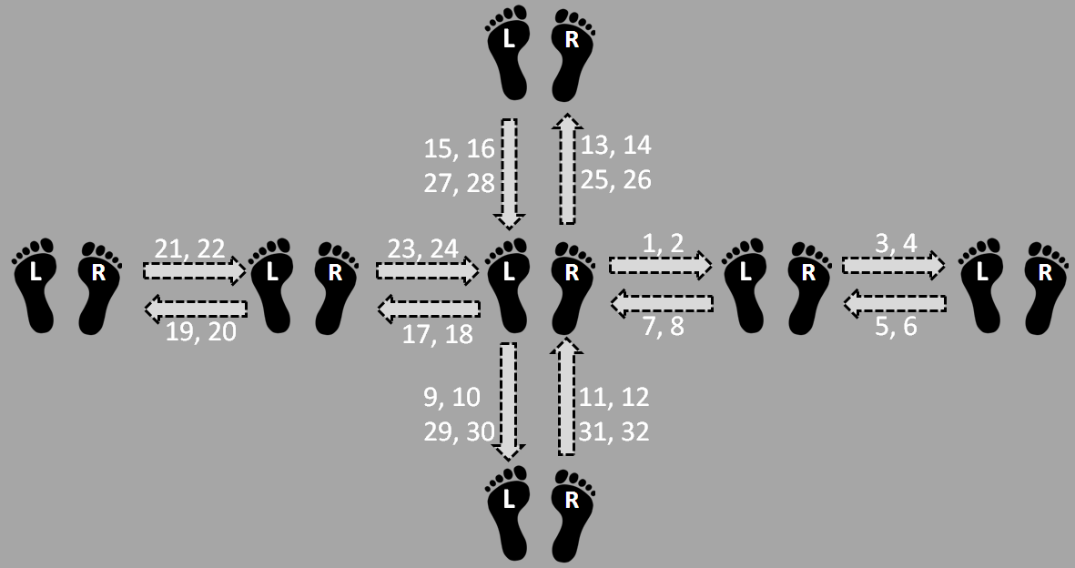
Fig 8: Modified Electric Slide Dance.

The independent researcher was given oral instructions (30 minutes) on the components of the belt and its complete operation including its software. The researcher was then allowed to configure the belt to his application. It took him 20 minutes to affix eight tactors and a control box, wire them together, and place them in the desired configuration. It took about 15 minutes to implement the vibrotactile cues for basic dance movements (left foot forward, right foot forward, etc.), and another 20 minutes to concatenate them into two dance sequences (modified box step and modified electric slide).

Aim
To evaluate the usability (see Table 1) of our vibrotactile belt, we relied upon survey questionnaires completed by participants after the experiment. To evaluate the functionality and the performance, we relied upon the survey questionnaire completed by the researcher who worked with our team on conducting the experiment. Both surveys asked questions that directly or indirectly captured the various elements provided in Table 1. The usability questions for participants were:
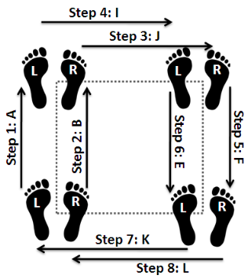
Fig 7: Modified Box Dance.
- How easy was it to put on the belt and adjust the location of the vibration motors?
- How easy was it to take off the belt?
- How easy was it to recognize vibrotactile patterns corresponding to specific body movements?
- How easy was it to move while wearing the belt?
- How unobtrusive was the belt?
- How comfortable was the belt?
- How ergonomic was the belt?
- How lightweight was the belt?
- How well did the belt fit your waist size?
- How would you rate the belt’s physical discreetness?
- How silent were the belt vibration motors?

The functionality and performance questions for the researcher were:
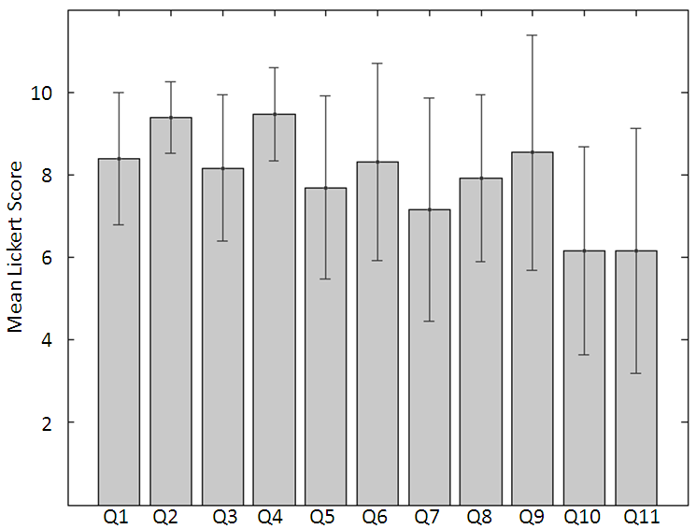
Fig 9: Usability Results.
- How easy was it to create your desired configuration of the belt, which involved adding/remove tactors, moving tactors around, wiring, etc. (take into account scalability and reconfigurability)?
- How easy was it to design your desired vibrotactile patterns using the GUI (take into account the expressiveness of the system, and GUI usability)?
- Was the portability of the belt, in terms of wearability and wireless capabilities, suitable for your intended application?
- Was the durability of the belt suitable for your intended application?
- Was the reliability of the belt suitable for your intended application?
- Was the wireless communication latency suitable for your intended application?
- Was the battery life suitable for your intended application?

In order to determine how well the experiment itself faired, we devised 5 research hypotheses for objective evaluation:
- Subjects will achieve at least 90% accuracy at absolute identification of spatio-temporal patterns.
- Subjects will achieve at least 85% accuracy at absolute identification of the individual moves of the modified box step dance.
- Subjects will achieve at least 85% accuracy at absolute identification of the individual moves of the modified electric slide dance.
- No one spatio-temporal pattern is more difficult to identify than the other.
- The moves of neither dance—modified box step or modified electric slide—will be more difficult to recognize than the other.

Other than the objective evaluations, participants were asked questions directed towards the dance experiment itself:
- How easy was it to recognize the vibrotactile patterns?
- How intuitive was the mapping between vibrotactile patterns and movements you had to perform?
- In the second part of the testing phase, you learned how to perform a dance sequence. How well did you learn the dance through use of the vibrotactile patterns?
- If you wanted to learn how to dance someday, how likely are you to use this system?
- Do you think others would like to use this system to learn dance?
- Have you danced before?
- If you have danced before, how many years?
- What is your preferred style of dance?

Results

Usability:
In order to understand the usability of the haptic belt through the subjective evaluation survey, we performed a one-way ANOVA on the data presented in Fig. 9. Considering a 5% significance test on the null-hypothesis that there is no significant difference in the means of the 11 usability questions, a 10 DoF along the questions axis, and 11*(13-1) = 132 DoF along the participant axis, F test results in [F(10,132)=3.29, p=0.0008], thereby rejecting the null hypothesis. Further, as a post-hoc analysis, a Multiple Comparison Procedure on the linear one-way ANOVA (with significance level α=0.05) shows that with respect to question 2 (How easy was it to take off the belt?) and question 4 (How easy was it to move while wearing the belt?), question 10 (How would you rate the belt’s physical discreetness?) and question 11 (How silent were the belt vibration motors?) are significantly different, thereby contributing to the rejection of the null hypothesis. On reviewing the descriptive evaluation provided by the participants on the haptic belt, it was discovered that question 10 relating to the physical discreteness was rated low due to the bulkiness of controller box on the belt. For question 11, referring to the noise made by the vibration motors, a redesign of the tactor modules is necessary to ensure that the vibration motors are enclosed rigidly within the tactor module.
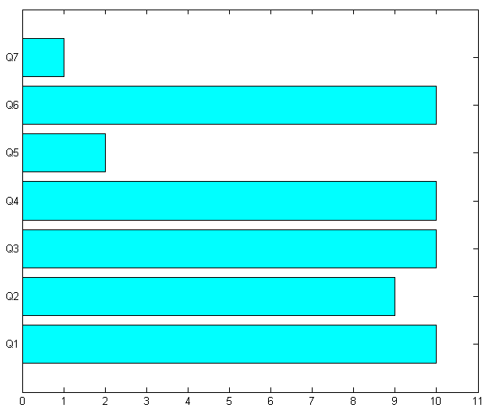
Fig 10: Functionality and Performance Results.

Question 4, relating to how easy it was to move wearing the belt, had the highest mean value of 9.46 (SD 1.13). This question relates to the important aspect of whether the belt allows the participants to move freely wearing the device. Any research platform has to offer this movement flexibility so that the hindrance due to the platform does not bias the user’s opinion of the experiment’s research questions. It was also seen that it was easy to take off the belt (Question 2) when compared to putting it on and adjusting the location of the vibrators (Question 1). The results are obvious as removing the belt necessitated only releasing the plastic snap buckle, whereas, wearing the belt and locating the motors necessitated the participant’s attention and effort.

Functionality and Performance:
Fig. 10 shows the responses of the independent researcher to the seven questions on functionality and performance. Since the belt was reviewed by one independent researcher, no formal statistical analysis can be done on the results. We report here our observations from what the researcher offered as explanations to his survey. No problems were experienced by the researcher when reconfiguring the belt or designing spatio-temporal patterns. In terms of the performance of the belt, portability, durability and wireless communication latency were found to be fine. As can be seen from Fig. 10, the two important drawbacks in terms of functionality and performance were found in a) the reliability of the belt for the intended application (Question 5) and b) the battery life of the haptic belt (Question 7). The failure to meet the necessary battery life on the belt was realized by the developers through the experimental study itself. The choice of battery manufacturer turned out to be a problem and has little or nothing to do with the design of the power supply module for the belt. We also realized that the researcher found the battery issue to be the main reason to consider the reliability of the belt to be low or not up to expectation.

Quantitative Evaluation of the Dance Experiment:
Fig. 11 shows participants’ recognition accuracies on the 12 spatio-temporal patterns that were delivered as part of the dance experiment. The overall recognition accuracy of vibrotactile patterns, averaged across participants, was 97% (SD: 4.6%). The average accuracy for recognizing the individual moves of the modified box step dance was 88% (SD: 20%), and the average accuracy for recognizing the individual moves of the modified electric slide was 95% (SD: 7.5%). Fig. 11 shows the results of the experiment where the participants performed the 12 patterns based on the 12 spatio temporal sequences. These results support hypothesis (1), showing that overall, participants had no difficulty recognizing the vibrotactile patterns. Using a one-way ANOVA, no significant difference [F=1.87, p=0.0475] between average recognition accuracies of vibrotactile patterns was found. This supports hypothesis (4), and shows that no single pattern was more difficult to recognize compared to the others. These results also support hypotheses (2) and (3), showing that participants were able to link moves together to perform some basic dances. A one-way ANOVA was applied to the accuracies achieved on the two dances, revealing no significant difference [F=1.55, p=0.2255] between the average recognition accuracies of the two dances (modified box step and modified electric slide). This supports hypothesis (5), and shows that participants didn’t find one dance more difficult than the other, even though the electric slide is longer and more complex than the box step. However, 3 out of the 13 participants scored very low on the modified box step dance, after which they performed very well on the more complex electric slide dance. We hypothesize that, for these participants, additional learning beyond the familiarization phase was required to learn how to link movements together; we believe that this learning took place during the modified box step dance steps. Reversing the dance sequences may have avoided this, but we feel that performing box step dance before the electric slide dance facilitated learning, as the box step dance is easier than the electric slide.
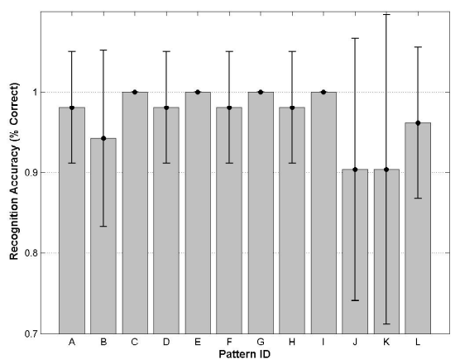
Fig 11: Pattern Recognition Results for Dance Experiment.
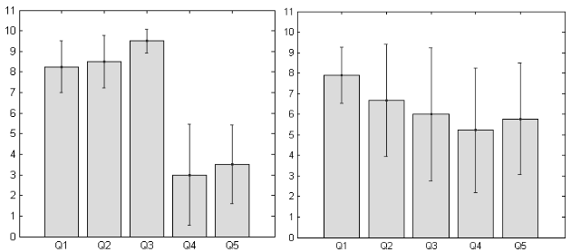
(a) (b)
Fig 12: Questionnaire Results from Dance Experiment for Experienced Dance Participants (a) and Inexperienced Dance Participants (b). Responses from Q6-Q8 are excluded.

Subjective Evaluation of the Dance Experiment:
Fig. 12 shows the subjective user responses for questions 1 through 5 based on whether the participants were experienced in dancing or not. Questions 6 through 8 explored the participants dance experience level, and we found on average, participants had no experience with dancing to about 5 years. We set the average of all user experience (1.8 years) as a threshold to decide whether participants were experienced or not.
Fig. 12(a) shows the results of participants who were experienced (mean experience of 5.12 years), and (b) shows the results of participants who were inexperienced (mean experience 0.44 years). From Fig. 12, it can be seen that the participants' opinions varies widely between the experienced and inexperienced groups, except for question 1, which enquired about the ease of recognizing the spatio-temporal patterns. The mean response for question 1 was 8 (SD 1.16). When the participants were asked how intuitive (Question 2) and useful (Question 3) the spatio-temporal patterns were, the experienced group seemed to desire having this sensory augmentation more than the inexperienced group. Correlating this to the quantitative analysis, the experienced group achieved 99% accuracy (SD: 1.8%) in recognizing all the 12 spatio-temporal patterns, whereas, the inexperienced participants achieved 95% accuracy (SD: 5.2%). We hypothesize that the experienced dancers had no problem executing the dance step and hence could focus on the vibrotactile pattern, whereas the inexperienced participants had to consciously process the haptic cues and the movements. When the participants were asked how likely they would use this device again (Question 4), or suggest this device to someone else (Question 5) to learn dance, the results seem to indicate opposite of what was seen in the previous two questions. The experienced dancers found this device rudimentary and not recommendable, whereas the inexperienced dancers seem to reluctantly agree to using or suggesting a sensory augmentation.

Conclusion and Future Work
In this paper, pragmatic design considerations for a vibrotactile belt are enumerated which caters to a derived set of functional, performance and usability requirements. A vibrotactile belt based on the proposed design guidelines is implemented and evaluated through a novel pedagogical case study. Participants of the experiment were taught choreographed dance through vibrotactile spatio-temporal patterns, and the belt was evaluated objectively and subjectively through task performance and survey questions, respectively. The goal of the case study was to show that our proposed design requirements provide for a versatile and usable vibrotactile belt. In the discussions of results, various drawbacks of the prototype belt are highlighted. From the time of the case study, a) the control box has been drastically reduced in dimensions to accommodate participant needs of ergonomic and lightweight design, b) the tactor module has been redesigned into a smaller form factor and the vibratory motor has been located within a plastic based adhesive to reduce noise, while maintaining the vibration intensity, and c) newer battery packs have been replaced to ensure at least 3 hours of continuous operation without needing a recharge.
As part of future work, we are currently working toward general design guidelines for any vibrotactile wearable device. Ultimately, we hope to design a modular, plug-and-play platform where any form factor vibrotactile wearable device could be easily constructed. Further we would like to investigate the possibilities of extending our platform to incorporate modular sensors (for sensing motion, temperature, location, etc.) along with actuators in standalone wireless self-contained units. Such a system would allow rapid prototyping of sensor-actuator systems, and allow exploration of novel human machine interfaces. Work is in progress to place the hardware design, firmware design, and the spatio-temporal rhythm pattern software designing tool onto the Open Source Public Domain.

References
- N. Edwards, J. Rosenthal, D. Moberly, J. Lindsey, K. Blair, S. Krishna, T. McDaniel, and S. Panchanathan, “A pragmatic approach to the design and implementation of a vibrotactile belt and its applications,” in Proc. IEEE HAVE, pp. 13-18, 2009.
- H.Z. Tan and A. Pentland, “Tactual displays for sensory substitution and wearable computers,” Fundamental of Wearable Computers and Augmented Reality, edited by W. Barfield and T. Caudell, Mahwah, NJ: Lawrence Erlbaum Associates, 2001.
- L.A. Jones and N.B. Sarter, “Tactile displays: guidance for their design and application,” Human Factors, vol. 50, pp. 90-111, Feb. 2008.
- F.A. Geldard, “Adventures in tactile literacy,” American Psychologist, vol. 12, no. 3, pp. 115-124, 1957.
- L.A. Jones and K. Ray, “Localization and pattern recognition with tactile displays,” In Proc. Haptics Symposium, pp. 33-39, 2008.
- F.A. Geldard and C.E. Sherrick, “The cutaneous rabbit: a perceptual illusion,” Science, vol. 178, pp. 178-179, 1972.
- S. Brewster and L. Brown, “Tactons: structured tactile messages for non-visual information display,” in Proc. AUIC, pp. 15-23, 2004.
- A. Chang, S. O'Modhrain, R. Jacob, E. Gunther, and H. Ishii, “ComTouch: design of a vibrotactile communication device,” in Proc. of the 4th ACM Conference on Designing Interactive Systems: Processes, Practices, Methods, and Techniques, pp. 312-320, 2002.
- J. Cha, M. Eid, L. Rahal, and A. El Saddik, “HugMe: an interpersonal haptic communication system,” in Proc. IEEE HAVE, pp. 99-102, 2008.
- J. Werner, R. Wettach, and E. Hornecker, “United-pulse: feeling your partner's pulse,” in Proc. ACM MobileHCI, pp. 535-538, 2008.
- J.B.F.V. Erp, H.A.H.C.V. Veen, C. Jansen, and T. Dobbins, “Waypoint navigation with a vibrotactile waist belt,” ACM Trans. Appl. Percept., vol. 2, pp. 106-117, 2005.
- W. Heuten, N. Henze, S. Boll, and M. Pielot, “Tactile wayfinder: a non-visual support system for wayfinding,” in Proc. ACM NordiCHI, pp. 172-181, 2008.
- K. Tsukada and M. Yasumura, “ActiveBelt: belt-type wearable tactile display for directional navigation,” in Proc. UbiComp, pp. 384-399, 2004.
- C. Wall and M.S. Weinberg, “Balance prostheses for postural control,” IEEE Engineering in Medicine and Biology Magazine, vol. 22, pp. 84-90, 2003.
- R. Lindeman, Y. Yanagida, H. Noma, and K. Hosaka, “Wearable vibrotactile systems for virtual contact and information display,” Virtual Reality, vol. 9, pp. 203-213, 2006.
- A.H. Rupert, “An instrumentation solution for reducing spatial disorientation mishaps,” IEEE Engineering in Medicine and Biology Magazine, vol. 19, pp. 71-80, 2000.
- J. van Erp and H.A. van Veen, “A multi-purpose tactile vest for astronauts in the international space station,” in Proc. Eurographics, pp. 405-408, 2003.
- R. Cholewiak, C. Brill, and A. Schwab, “Vibrotactile localization on the abdomen: effects of place and space,” Perception & Psychophysics, vol. 66, pp. 970-987, 2004.
- S. Krishna, V. Balasubramanian, D. Colbry, S. Panchanathan, and T. McDaniel, “Using a haptic belt to convey non-verbal communication cues during social interactions to individuals who are blind.,” in Proc. CVAVI, A Satellite Workshop of ECCV, 2008.
- J. Erp, “Guidelines for the use of vibro-tactile displays in human computer interaction,” in Proc. Eurohaptics, pp. 18-22, 2002.
- A. Ferscha, B. Emsenhuber, A. Riener, C. Holzman, M. Hechinger, D. Hochreiter, A. Franz, A. Zeider, M.D.S. Rocha, and C. Klein, “Video Paper: Vibro-tactile space awareness,” in Proc. of the 10th International Conference on Ubiquitous Computing, 2008.
- J. Ryu and S. Choi, “posVibEditor: graphical authoring tool of vibrotactile patterns,” in Proc. IEEE HAVE, pp. 120-125, 2008.
- J. Lieberman and C. Breazeal, “Development of a wearable vibrotactile feedback suit for accelerated human motor learning,” in Proc. IEEE ICRA, pp. 4001-6, 2007.
- R.W. Lindeman, Y. Yanagida, K. Hosaka, and S. Abe, “The TactaPack: a wireless sensor/actuator package for physical therapy applications,” in Proc. Haptics Symposium, pp. 337-341, 2006.
- D. Drobny, M. Weiss, and J. Borchers, "Saltate!: a sensor-based system to support dance beginners," in Proc. of the 27th ACM International Conference Extended Abstracts on Human Factors in Computing Systems, pp. 3943-8, 2009.
- D. Spelmezan, M. Jacobs, A. Hilgers, and J. Borchers, “Tactile motion instructions for physical activities,” in Proc. ACM CHI, pp. 2243-52, 2009.
- J.V.B. Linden, E. Schoonderwaldt, and J. Bird, “Good vibrations: guiding body movements with vibrotactile feedback,” in Proc. of the Third International Workshop on Physicality, pp. 13-18, 2009.
- T. Grosshauser and T. Hermann, "Augmented haptics--an interactive feedback system for musicians," in Proc. HAID, pp. 100-8, 2009.
- K. Förster, M. Bächlin, and G. Tröster, “Non-interrupting user interfaces for electronic body-worn swim devices,” in Proc. ACM PETRA, pp. 1-4, 2009.
- A. Nakamura, S. Tabata, T. Ueda, S. Kiyofuji, and Y. Kuno, "Multimodal presentation method for a dance training system," in Proc. of the International Conference Extended Abstracts on Human Factors in Computing Systems, pp. 1685-88, 2005.

http://funnel.cc
http://sites.google.com/site/hapticplatform/

